## Configuring SharePoint Server 2010 Search

**Lab Time**: 45 minutes

**Lab Folder**: C:\Student\Labs\09.Search

**Lab Overview**: Now that you’ve spent quite a bit of time using SharePoint 2010 and are becoming familiar with the ins and outs of the program, let’s take a look at how to configure and use SharePoint’s search features. Search was one of the many service applications created during the initial configuration of our farm, but it requires some additional TLC which we haven’t given it yet. Even though the Search Service Application has been set up, it isn’t working yet, so let’s get started before the users start complaining that they are getting no results when they search for documents.

### Exercise 1: Create Some Content to Search

You will begin by adding some content to the Wingtip Intranet Site. This will provide a source of content for searching in later lab exercises.

1. Launch Internet Explorer and navigate to http://intranet.wingtip.com**.**
2. View all of the site’s content by selecting **Site Actions » View All Site Content.**
3. Upload some Top Secret Product X documents
   1. Under the **Document Libraries** section, click **Site Collection Documents.**
   2. In the Ribbon, click the **Documents** tab.
   3. In the Ribbon, click **Upload Document.**

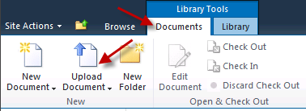

* 1. Click the **Browse** button.
  2. Navigate to Open [[Lab Files]]\Starter Files**.**
  3. Select Product X Design.docxand click **Open.**
  4. Click **OK** on the **Upload Document** window.
  5. Click **Save** on the **Shared Documents –** Product X Design**.docx** window.
  6. Repeat these stepsfor the documents Product X Details.docx andProduct X Test Results.docx**.**

### Exercise 2: Configuring the Search Application Service

Now that you have created an instance of the Search Service Application, it is time to begin configuring it.

1. Launch Central Administration if it is not already open and navigate to the home page. Click the link in the **Application Management** section with the caption of **Manage service applications**.
2. Review the options available for the Search Service Application. Scroll down the list of Service Applications and select the line for **Search Service Application.**

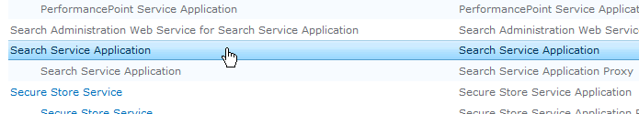

1. In the ribbon, click the **Properties** button to open the properties of the **Search Service Application**. Inspect the **Property** settings available in the Properties page. You should be able to verify the property values that were set during the configuration of your SharePoint farm.

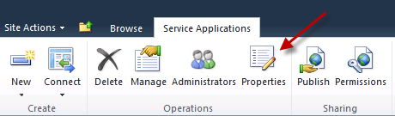

1. Click the **Cancel** to close the Properties page when you are done.
2. Back on the **Manage service applications** page, make sure the **Search Service Application** is selected and then click the **Manage** button in the ribbon.

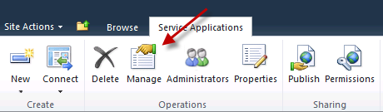

You might ask yourself, “What’s the difference between Properties and Manage?” Well, Properties are the properties of the service application itself, whereas Manage lets you control the search-specific settings.

1. You should now be at the **Search Administration** home page. You might recognize many of the items on this page from the Search Settings page in SharePoint 2007

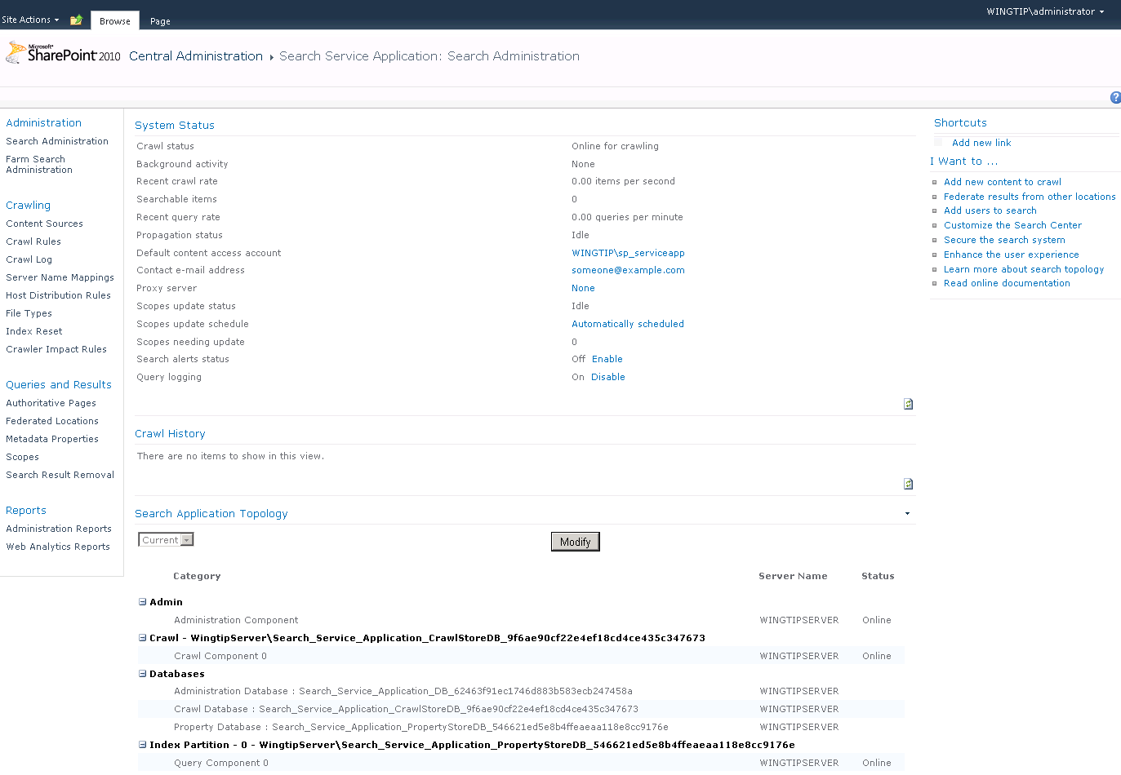

1. Scroll down and notice that there is no information in the **Crawl History**, and also that you can modify the topology of Search in SharePoint 2010, giving you more flexibility in how Search is set up. You won’t be changing anything in this section in this lab.
2. In this step you will modify an existing content source so it does not crawl the content in the Web application at http://intranet.wingtip.com.
3. In the **Quick Launch** bar, click **Content Sources**

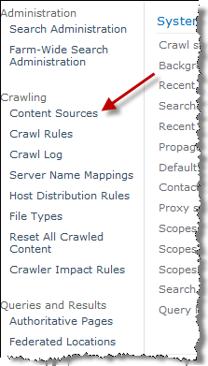

* 1. Hover over the **Local SharePoint sites** content source, **click the dropdown arrow**, and then select **Edit.**

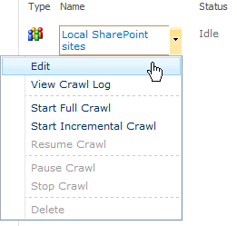

* 1. Scroll down to the **Start Addresses** section and highlight http://intranet.wingtip.com and delete it**.**

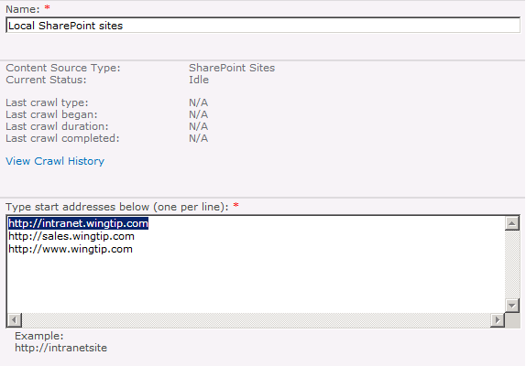

* 1. Scroll to the bottom of the page and click **OK** to save you changes to this content source.

1. Now add a second content source that will only crawl the content in the site collection at
2. In the toolbar, click **New Content Source**.

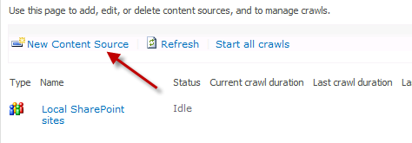

* 1. For the new Content Source’s **Name**, type **Wingtip Intranet**
  2. In the **Content Source Type** section, leave **SharePoint Sites** selected
  3. In the **Start Addresses** section, type in [http://intranet.wingtip.com](http://portal.wingtip.com).

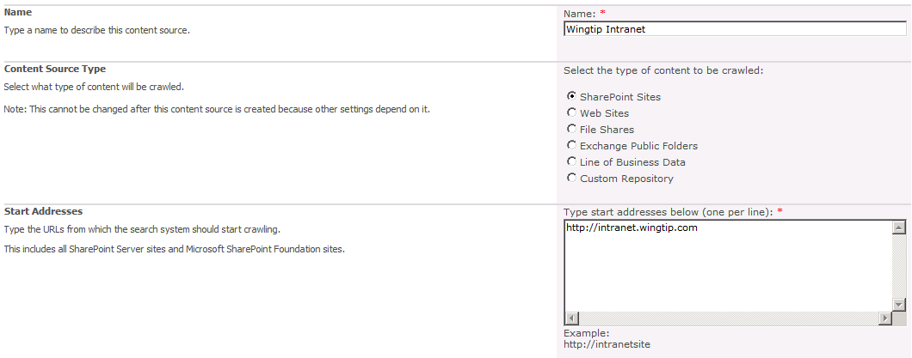

* 1. In **Crawl Settings**, select the option for **Only crawl the Site Collection of each start address**.

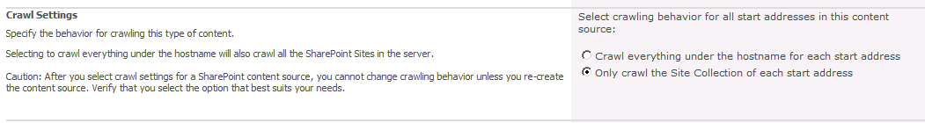

* 1. Keep the rest of the options on this page as their default, scroll to the bottom of the page, and click **OK** (We will set up a crawl schedule in a bit).

Using these steps is also how you could add an additional content source to crawl, such as a file system share or non-SharePoint web content.

1. While you’re at it, check the list of file types included in the search index by default
2. In the Quick Launch, click the **File Types** link
   1. Scroll down the list and look for the PDF file type
   2. You didn’t see it, did you? That’s because PDF isn’t included by default in the search index

### Exercise 3: Set up SharePoint Search to Crawl PDF files

One issue many SharePoint administrators ran into in SharePoint 2007 was the fact that the contents of PDF documents uploaded into document libraries were not able to be included in search results without some finagling. Well, the story is pretty much the same in SharePoint 2010. Without a PDF IFilter and a couple tweaks, SharePoint Search still just assumes a PDF document is just some kind of generic file and completely ignores its contents. Let’s teach SharePoint a thing or two about PDFs.

1. Install the FoxIt PDF IFilter.
2. Navigate to **[[Lab Files]]\Starter Files**
   1. Locate and double-click the PDF iFilter installation file named **Foxit_PDF_IFilter_SVR_20_0519_64.msi.**
   2. Follow the steps of the installation program to install the Fox IT PDF iFilter.
3. Add the PDF file type to the File Types crawled by Search.
4. Switch back over to the open Internet Explorer window, which should still be open to the Manage File Types screen.
   1. Click **New File Type.**

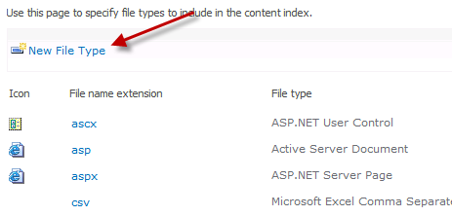

* 1. In the File Extension: field, type pdf.
  2. Click **OK.**
  3. Scroll down the list and notice that although PDF has been added to the list, it doesn’t have a fancy icon associated with it.

1. Add a PDF icon for the PDF file type in SharePoint’s Images folder.
2. In the Windows Explorer, navigate to Navigate to **[[Lab Files]]\Starter Files**.
   1. Right-click on the PDF.gif file and select **Copy.**
   2. Navigate to C:\Program Files\Common Files\Microsoft Shared\Web Server Extensions\14\TEMPLATE\IMAGES**.**
   3. Right-click in an empty area and select **Paste** to paste in the PDF.gif icon.
3. Open the DOCICON.xml file
4. In the folder’s address bar, click the **TEMPLATE** link to open the TEMPLATE folder.

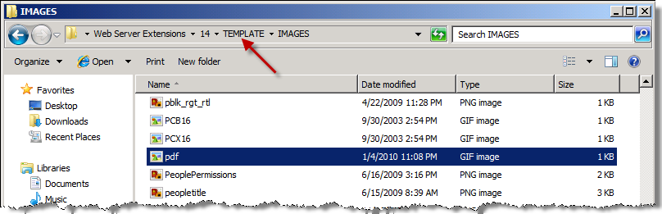

* 1. Find the XML folder and double-click to open it
  2. Look for the DOCICON.XML file. When you find it, **right-click** it and select **Open With » Notepad.**

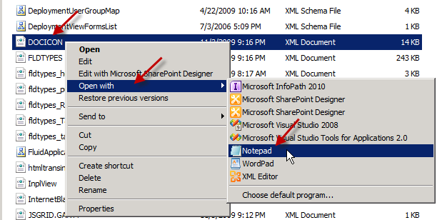

* 1. This file controls which icons display with each type of file extension.

1. Add the PDF file type to the DOCICON.xml file.
2. In the <ByExtension> section, add a new line and type.

<Mapping Key="pdf" Value="pdf.gif"/>

NOTE: It might be easier to copy and paste one of the existing entries and modify the Key and Value properties.

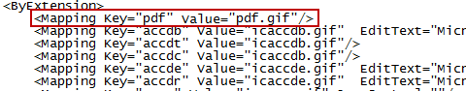

* 1. Click **File » Save** to save the file.
  2. Close Notepad and Windows Explorer.

Note – if you wanted to keep the <ByExtension> section in alphabetical order, you could insert the line above <Mapping Key="png" Value="png.gif"/>.

1. Check to see if the PDF Icon is showing up for the PDF file type.
2. Switch back to Internet Explorer, which should still be on the File Types screen.
   1. **Refresh** the page and scroll down to find the PDF entry. Hey, what gives? All that work and no PDF icon?
3. Perform an IISRESET to see if that helps.
4. Click **Start » Run…**
   1. Type iisreset and press [Enter]**.**
   2. When the command window closes, refresh the page again. Refresh is very slow this time since the IISRESET cleared SharePoint’s cache from memory, forcing it to load all its files again – including DOCICON.xml.
   3. The PDF icon is now showing up.

### Exercise 4: Setting up a Crawl Schedule

Although Search is essentially ready to go now that we’ve made a few changes to its settings, it doesn’t come configured with a crawl schedule so it just sits there, twiddling its thumbs, waiting for you to give it something to do. The way we do this is by setting up a crawl schedule.

1. Set up the Crawl Schedule for the Local SharePoint sites content source.
2. In the Quick Launch area, click **Content Sources.**
   1. Hover over the **Local SharePoint sites** source, click the dropdown arrow, and select **Edit.**
   2. Scroll down to the **Crawl Schedules** section.
   3. Under the **Full Crawl** dropdown, click **Create Schedule**.

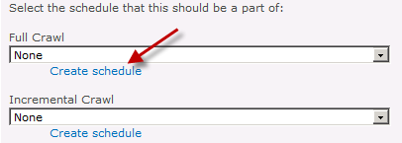

* 1. Use the default values and click **OK.**
  2. Under **Incremental Crawl**, click **Create Schedule.**
  3. Leave the **Daily** radio button checked.
  4. Set the **Starting time**: to **2:00 AM.**
  5. Check **Repeat** within the day.
  6. Every: **120 minutes.**
  7. For: **1260 minutes** (1260 minutes=21 hours).

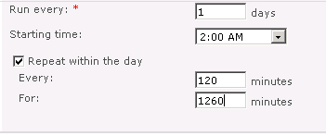

* 1. Click **OK**

You’ve just set up a Full Crawl to start every night at midnight. Then, at 2:00 AM, the Incremental crawl kicks off once every two hours. The last incremental crawl will be at 10:00 PM. This way, the crawls never overlap one another.

1. Start a full crawl of the Local SharePoint sites content source.
2. Scroll down to the bottom of the Edit Content Source page and check the box for **Start full crawl of this content source**



* 1. Click **OK** to save the changes and start a full crawl
  2. Back on the Manage Content Sources screen, you’ll notice that status of the crawl is displayed for Local SharePoint sites, just like it was in SharePoint 2007. This crawl will take approximately 15 minutes to run

1. Configure a crawl schedule for the Wingtip Publishing Site content source
2. Hover over the **Wingtip Intranet** content source, click the dropdown arrow and select **Edit.**
   1. Scroll down to the **Crawl Schedules** section.
   2. Click **Create schedule** under **Full Crawl**.
   3. Set the Starting Time: to **1:00 AM.**
   4. Click **OK.**
   5. Under Incremental Crawl, click **Create Schedule.**
   6. Set the Starting time: to **1:00 AM.**
   7. Check Repeat within the day.
   8. Every: **60 minutes.**
   9. For: **1320 minutes.**

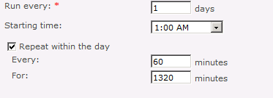

* 1. Click **OK**.

The full crawl will run at 1:00 AM every day, followed by an incremental crawl starting at 2:00 AM. The final incremental crawl will finish at 12:00 AM.

1. Start a full crawl of the Wingtip Publishing Site content source.
2. Scroll down to the bottom of the **Edit Content Source** page and check the box for **Start full crawl of this content source.**
   1. Click **OK** to save the changes and start a full crawl.
   2. This crawl takes about 10 minutes to finish, but you can continue the lab.

### Exercise 5: Build a Search Center

In this exercise you will create and customize a new search center site.

1. Open a New Tab in the browser and navigate to http://intranet.wingtip.com.
2. Log in as WINGTIP\administrator**.**
3. Enable the SharePoint Server Standard Site Collection Features and Search Center Web Parts Feature.
4. Click **Site Actions » Site Settings.**
   1. Under **Site Collection Administration**, click **Site collection features.**

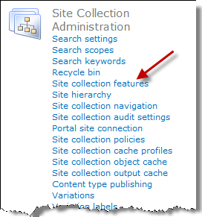

* 1. Scroll down to find the **Search Server Web Parts** Feature and click **Activate.**



* 1. Scroll down to find the **SharePoint Server Standard Site Collection** Features feature, and click **Activate.**



1. Create a Search Center site.
2. Click **Wingtip Publishing Site** in the top navigation to return to the homepage
   1. Click **Site Actions » New Site.**

NOTE: The next few steps assume that the Silverlight runtime is installed on the server. If your experience does not match the instructions or the following screenshot, install the Silverlight runtime located in the C:\Student\Resources folder. Once complete, close all instances of Internet Explorer, open a new instance of Internet Explorer and navigate to the http://intranet.wingtip.com site.

* 1. In the left column, click **Search.**
  2. Choose the **Enterprise Search Center** template**.**

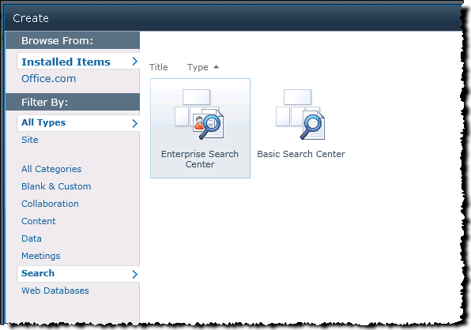

* 1. In the **Title** field on the right, type **Search Center**
  2. In the **URL** field below, type **searchcenter**
  3. Click **More Options**.
  4. In the **Description** field, type: **This is a centralized location for searching the site.**
  5. Click **Create.**

You created an Enterprise Search Center. Notice the tabs above the search box. The Enterprise Search Center template is extensible, meaning you can add your own tabs for specific search queries.

1. Try out the new Search Center.
2. In the Search box, type salesand press [Enter]**.**
   1. Notice that the results page shows results like SharePoint 2007, but with some added options in the left side of the page for refining your search.
   2. Under Modified Date, click **Past 24 Hours** to filter the search and only show items updated in the last 24 hours.

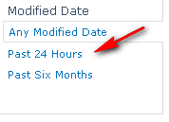

* 1. In the Search box, type produktand press [Enter].
  2. SharePoint’s search guesses what you meant to type and offers a suggestion just below the Search box. Click the link for the correct spelling ofproduct below the Search box and notice how the correct results are now displayed.

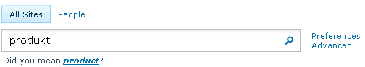

* 1. In the Search box, type filetype:docx productand press [Enter].
  2. Only *.docx files will show up containing the word “Project”.

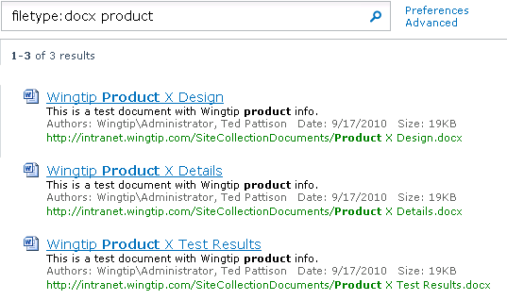

* 1. SharePoint 2010 can search using property:value syntax.

### Exercise 6: Create a Local Search Scope

In this exercise you will add a search scope to the Wingtip Intranet work site that will allow you to only search within that site without including results from the entire site.

1. Navigate to http://intranet.wingtip.com.
2. Add a search scope for the Wingtip Intranet site.
3. Click **Site Actions » Site Settings.**
   1. Under **Site Collection Administration**, click **Search Scopes.**

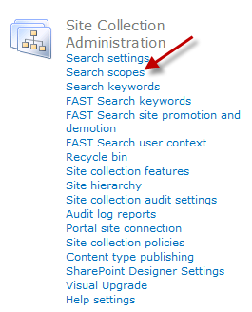

* 1. Click **New Scope.**
  2. For **Title:** type **Sales Only.**
  3. For **Description:** type **Search scope only for Wingtip Sales.**
  4. Check both boxes in the **Display Groups** section, for **Search Dropdown** and **Advanced Search.**
  5. Click **OK.**
  6. In the **Update Status** column, click **Add Rules.**

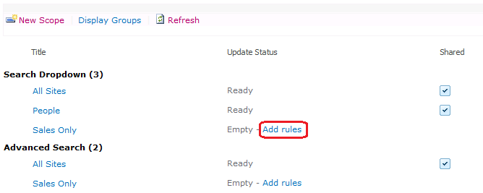

* 1. In the Folder: field, type http://intranet.wingtip.com/sites/sales.
  2. Click **OK.**

The scopes update automatically every 15 minutes, so you may need to wait for the scope to show up. In the meantime, there are a couple additional steps that need to be taken to show scopes in SharePoint 2010.

1. Turn on the Search Scope dropdown for the sales site
2. Click **Site Actions** » **Site Settings.**
   1. Under **Site Collection Administration**, click **Search settings.**
   2. Click the option to **Enable custom scopes** and type in the relative URL for the Search Center, /searchcenter/pages so sales site results are displayed there.
   3. In the **Site Collection Search Dropdown** Mode, select **Show scopes dropdown.**
   4. Click **OK.**
3. Check to see if the scope is working.
4. On the **Site Settings** page, click **Search scopes** under **Site Collection Administration** to see if the scope has updated yet.
   1. Once its status displays as **Ready**, click **Wingtip Publishing Site** in the site breadcrumb to return to the homepage.

If the scope hasn’t updated and won’t for a few minutes, you can trigger it to happen immediately. To manually update the scopes, go to the **Search Service Application** via Central Administration and click the link **Start Update Now** next to the **Scopes needing update** on the dashboard page.

* 1. Next to the search box will be the Scope dropdown box. **Click it** to see the new **Sales Only** scope.

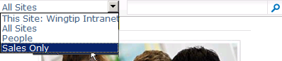

**Note:** If the Sales Only scope is not showing even if the status displays Ready, you may need to perform an IISRESET to clear SharePoint’s cache and force the new scope to display. Simply click **Start** and type iisreset and press[Enter]. Once the IISRESET completes, refresh the page and the scope should display.

### Exercise 7: Making Users Happy by Adding a Tab to the Search Center

In this exercise you will update the Search Center to include a tab that will let you search the Wingtip Intranet Site from the Search Center.

1. Open the Search Center.
2. Navigate to http://intranet.wingtip.com.
3. Click **Search Center** in the top navigation.
4. Create a Wingtip Intranet Search Page.
5. Click **Site Actions » View All Site Content.**
   1. Click **Pages.**
   2. In the Ribbon, click the **Documents** tab in the ribbon and click **New Document**.
   3. For **Title:** type **Wingtip Intranet Search.**
   4. For the **URL Name:** type wi_search**.**
   5. For the Page Layout, select **(Welcome Page) Search box.**
   6. Click the **Create** button.
6. Create a Wingtip Intranet Search tab on the Search Center page.
7. Click **Search Center** in the top navigation to return to the Search Center home.
8. Click **Site Actions » Edit Page**.
   1. Under the tabs, click the newly exposed option **Add New Tab**.



1. For the Tab Name, enter **Wingtip Intranet Search.**
2. For Page, type **wi_search.aspx.**
3. In the Tooltip field, type **Use this tab for searching Sales content.**
4. Click **Save.**
5. **Refresh** the page and the **Wingtip Intranet Search** tab will show up.



1. Create a Wingtip Intranet Results Page.
2. Click **Site Actions** » **View All Site Content**.
   1. Click **Pages**.
   2. In the Ribbon, click the **Documents** tab and click **New Document**.
   3. For Title: type **Wingtip Intranet Search Results.**
   4. For the URL Name: type **wi_results.**
   5. For the Page Layout, select **(Welcome Page) Search results.**
   6. Click **Create.**
3. Set the Wingtip Intranet Search Page to use the new results page for displaying search results.
4. Click the **Search Center** in the top navigation to return to the Search Center home.
   1. Click the **Wingtip Intranet Search** tab.
   2. Click **Site Actions » Edit Page.**
   3. Click the dropdown arrow for the **Search Box** Web Part and select **Edit Web Part.**

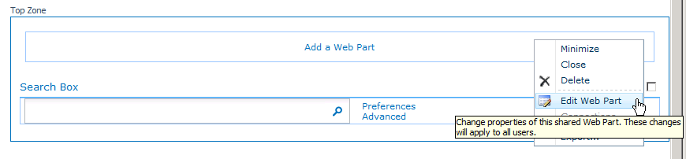

* 1. Scroll up and expand the **Miscellaneous** section in the tool pane at the right.

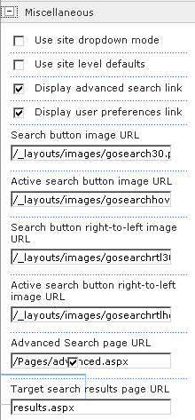

* 1. Find the **Target search results page URL** field and type in **wi_results.aspx.**
  2. Click **OK.**
  3. In the ribbon, click the **Publish** tab and click **Publish.**
  4. Click **Continue**.
  5. With the Wingtip Intranet Search tab selected, type **Wingtip** and press [Enter]. The results from the Wingtip Intranet Site will now show up on the Results page.

### Exercise 8: Create a Crawl Rule

In this exercise you will create a new crawl rule so that sensitive content is not crawled and cannot be searched.

1. Make a crawl rule to exclude the Marketing site from search.
2. Switch back to the **SharePoint 2010 Central Administration** and return to the **Manage** page of the Search service application.
   1. In the **Quick Launch** area, click **Crawl Rules.**
   2. The field above the big **Test** button lets you check to see if any rules are in effect for a URL typed into the field, however, since we don’t have any rules yet, just click the link **New Crawl Rule.**

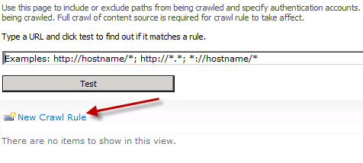

* 1. In the **Path:** text box, type the URL of the Marketing site, which is http://intranet.wingtip.com/sites/marketing.
  2. Make sure that the option to **Exclude all items in this path** is selected.

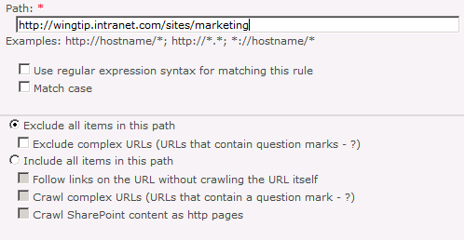

* 1. Scroll down and click **OK.**

In this exercise you created a new crawl rule.